**LIST OF EXPERIMENTS(NFA)**

**COURSE CODE : CSA1381**

**COURSE NAME : THEORY OF COMPUTATION**

**NAME : O. MURALI KRISHNA MOHAN**

**REG NO : 192125053**

**EXPERIMENT NUMBER 30:**

**Design NFA to accept any number of a’s where input={a,b} ?**

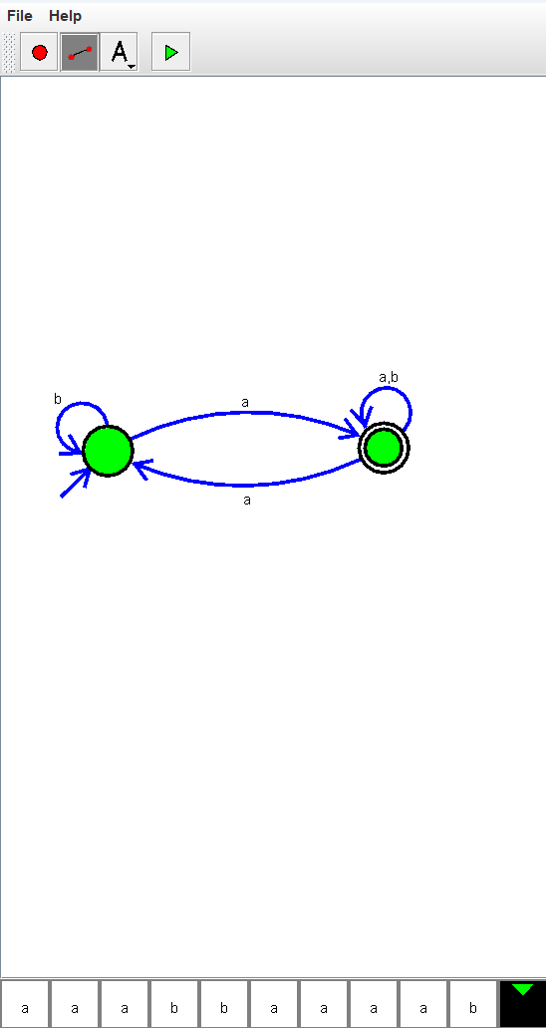

**EXPERIMENT NUMBER 36 :**

**Design NFA using simulator to accept the string the start with a and end with b over set {a,b} and check W= abaab is accepted or not.**

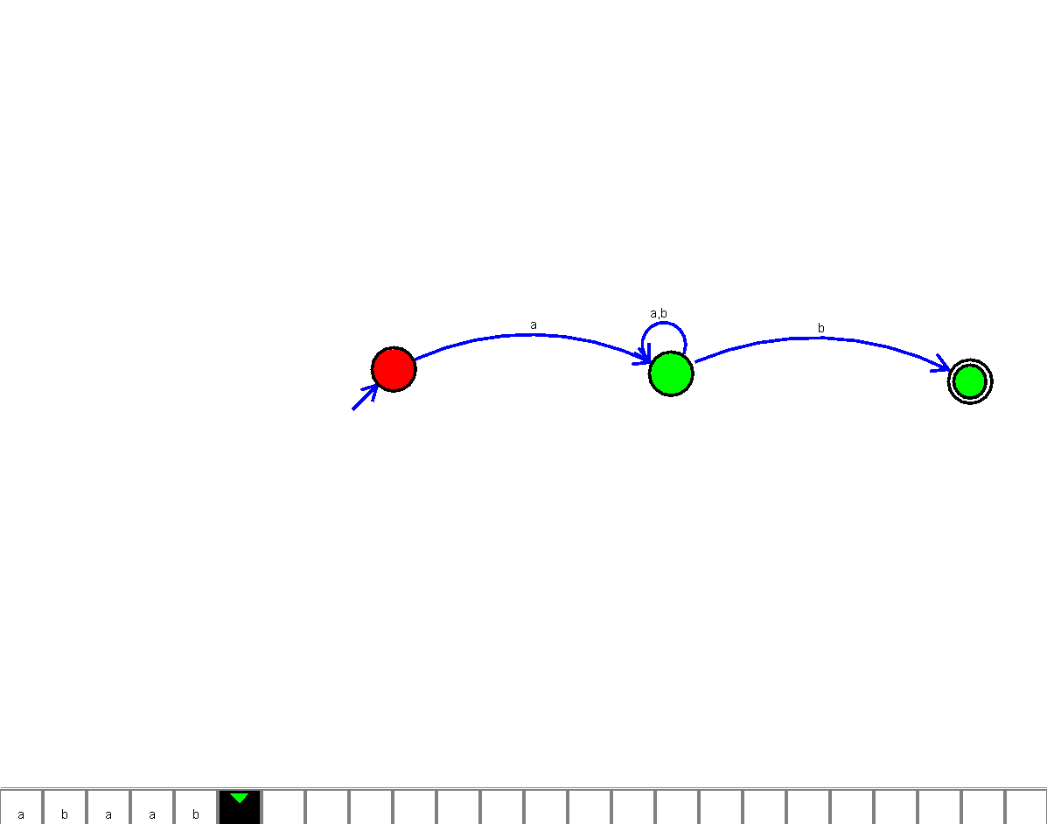

**EXPERIMENT NUMBER 37 :**

**Design NFA using simulator to accept the string that start and end with different symbols over the input {a,b} ?**

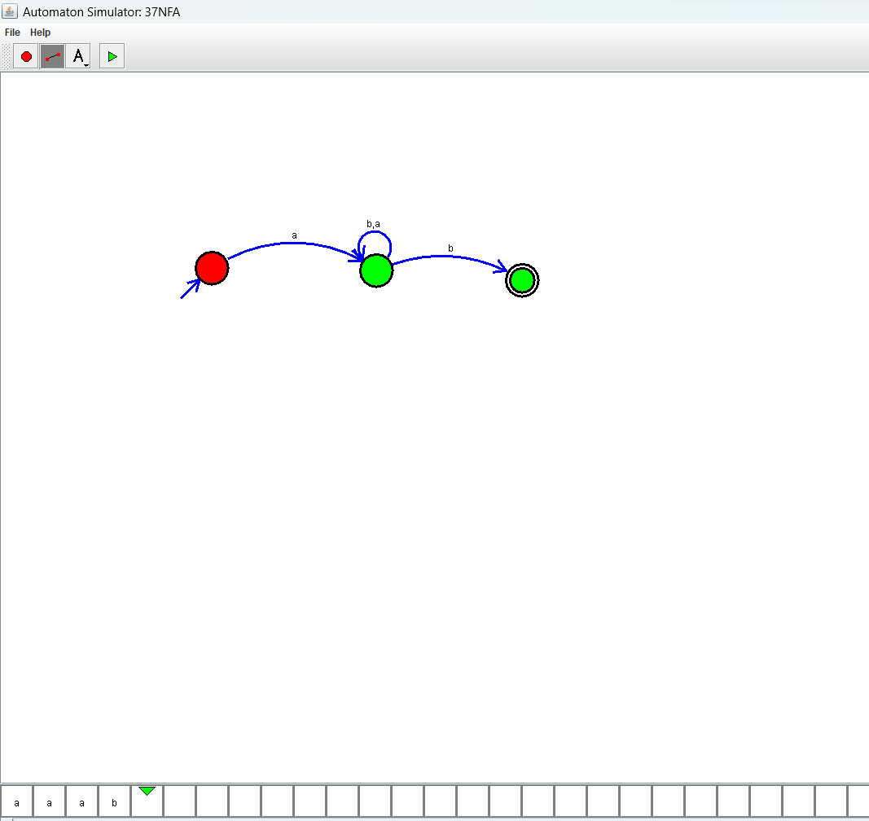

**EXPERIMENT NUMBER 38 :**

**Design NFA using simulator to accept the input string “bbc” ,”c”,and ”bcaaa”.**

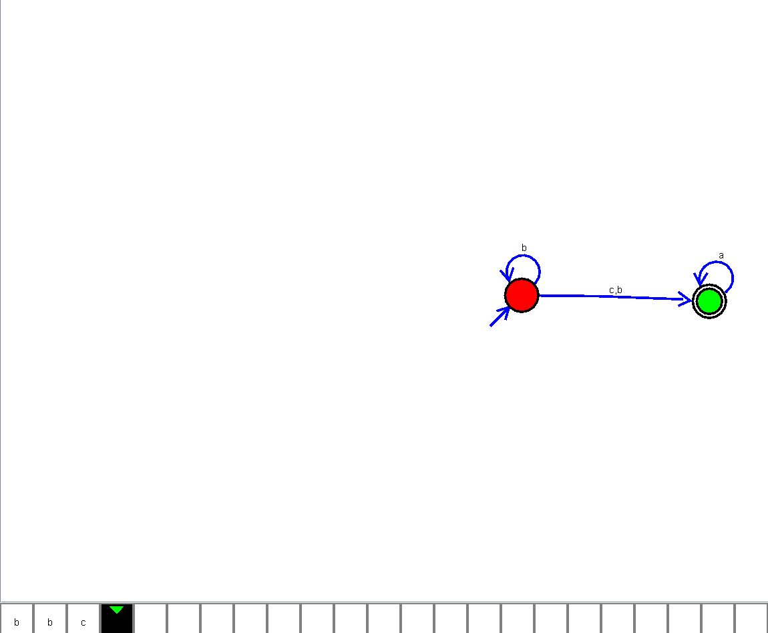

**EXPERIMENT NUMBER 40:**

**Design NFA to accept any number of b’s where input={a,b} ?**

